**A PROJECT REPORT ON**

**Capstone Project Planning Title**

**Submitted by**

**UNDER THE GUIDANCE OF IN PARTIAL FULFILLMENT OF**

**DIPLOMA IN COMPUTER ENGINEERING MAHARASHTRA STATE BOARD OF TECHNICAL**



**EDUCATION VIDYA PRATISHTHAN’S POLYTECHNIC**

**Mr. Bhuse S.H Prof. Veer R.A.**

**PROJECT GUIDE HOD PRINCIPAL**

**ACKNOWLEDGEMENT**

After the successful planning of our project, we overcome with a sense of gratitude towards those people, without whose support, guidance and cooperation this would never have been possible.

First and foremost, we would like to thanks our **H.O.D. Mr. Bhuse S. H.** for his valuable guidance which provided us with a perfect path on which we were able to successful planning our ideas.

We heartily like to thank our **Principal Mr. Veer R. A.** for their valuable support. Last but not least we would like to thank all our classmates and parents for their enthusiasm and great ideas.

**Submitted by**

**ABSTRACT**

Email is considered as one of the most pervasive form of communication. However, all these technologies can be of no use to the people who are visually impaired as all activities that can be performed on the computer are based on visual perception. With the advent of technologies in mobile phones, many technological solutions have been implemented for visually impaired so that they can utilize them, and get benefited by them. Considering it as a key idea application will be built that will help blind people to send and read emails as ordinary people do. Speech has not been used much in the field of electronics and computers due to the complexity and variety of speech signals and sounds. However, with modern processes, algorithms, and methods, the processing of speech signals easily and recognize the text. The application will not let the user to make the use of keyboard instead will work on text to speech and vice versa to facilitate sending, reading, forwarding and replying to emails using an android smart phone. The app will be developed this on android platform. Our speech-to-text module directly acquires and converts speech to text. Speech recognition is done via the Internet, connecting to Googles server.

**Chapter 1**

1. **Introduction of project :-**

As the title suggests, the application will be a web-based application for visually impaired persons using IVR- Interactive voice response, thus enabling everyone to control their mail accounts using their voice only and to be able to read, send, and perform all the other useful tasks. The system will prompt the user with voice commands to perform certain action and the user will respond to the same. The main benefit of this system is that the use of keyboard is completely eliminated, the user will have to respond through voice and mouse click only. Now you must be thinking that how will a blind person will see the correct position on the screen for doing mouse clicks. But this system will perform actions based on the clicks only that is left click or right click, it does not depend on the portion of the screen where the cursor is placed before the click giving user the freedom to click blindly anywhere on the screen.

1. **Problem Definition :-**

1. **Scope Of Project :-**

There is wide future scope of this system many enhancements can be done in the system such as including different languages, including functionality of accessing the deleted mails and spam mails. Also, this system can be enhanced such that it can also send attachments which are more beneficial for visually challenged people. This system can be made available to all regional people who are not educated enough and inclusion of different languages will make this system easily accessible. Further more sign language system can also be integrated with the system to make the system more scalable and robust.

CHAPATER 2

**2.1 Literature Survey /Comparison with Similar System :-**

Existing systems of today are basically applications that provide accessing and managing of emails benefits to its users via web facilities. Making email widely used communication form. The existing systems do not support any voice commands or audio facilities and therefore it is not suitable for visually challenged people. Also, there are various existing search engine which take request in form of text from user and retrieve the relevant documents from server and responds by displaying it in the form of text which is not possible for visually challenged people .

**CAHAPTER 3**

* 1. **Objective of project-**

* 1. **User Requirement-**
  2. **Hardware and Software Requirements**

**Hardware:**

8gb ram

I5 processor

512gb SSD

**Software:**

Windows 10 pro

PyCharm Editor

Text-to-speech API

Speech-to-text API

# Chapter 4

**4.0 System Design & Modelling:-**

1. Data Flow Diagrams

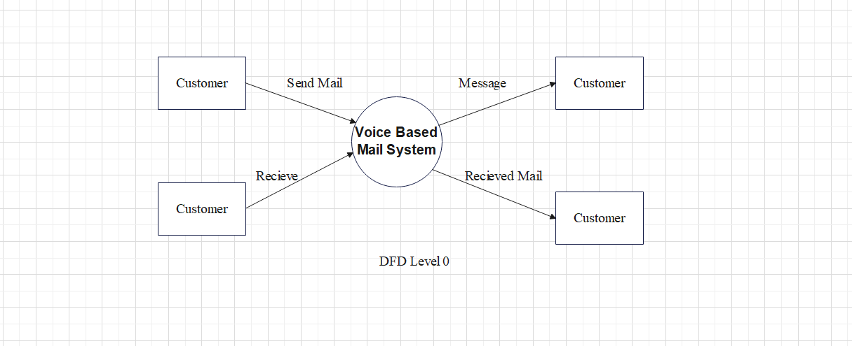

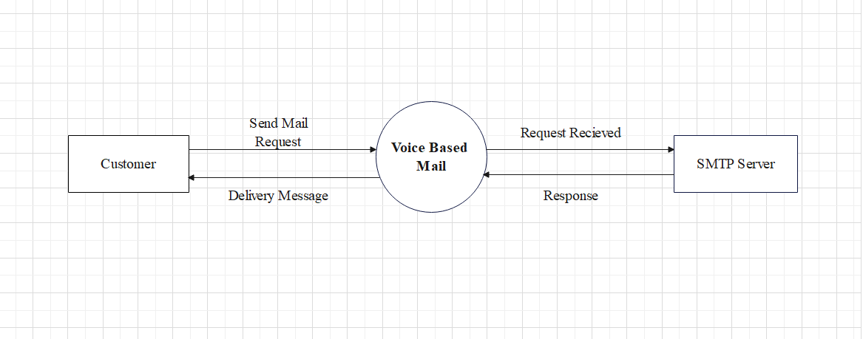

DFD level 1 (for send mail)

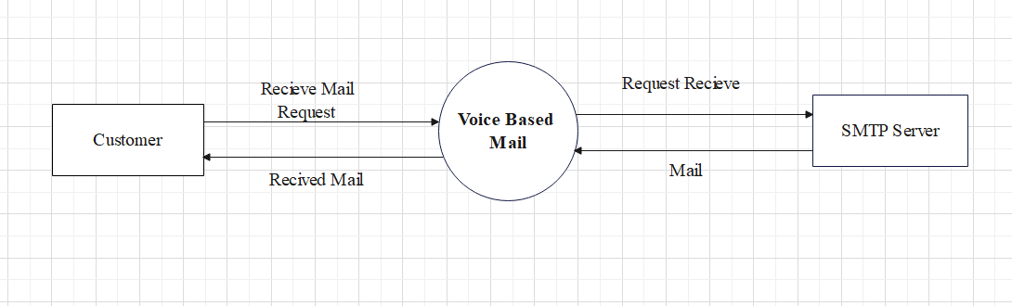

DFD level 1 (for receive mail)

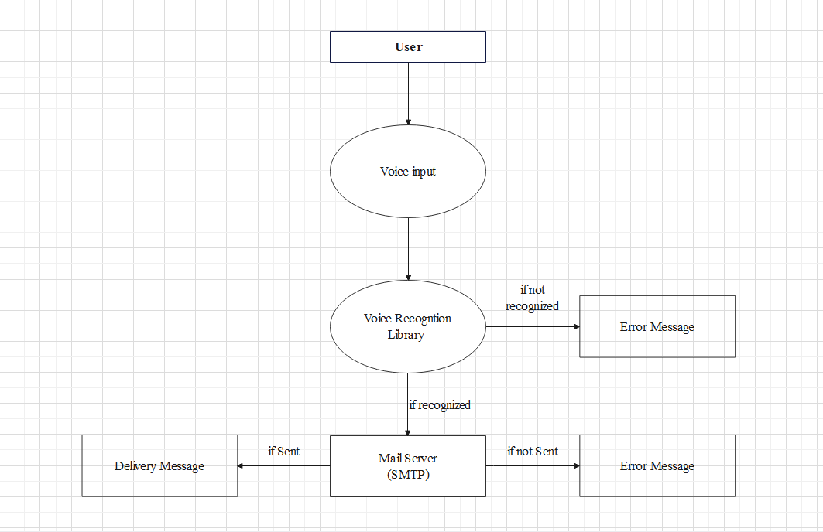

DFD level 2 (for send mail)

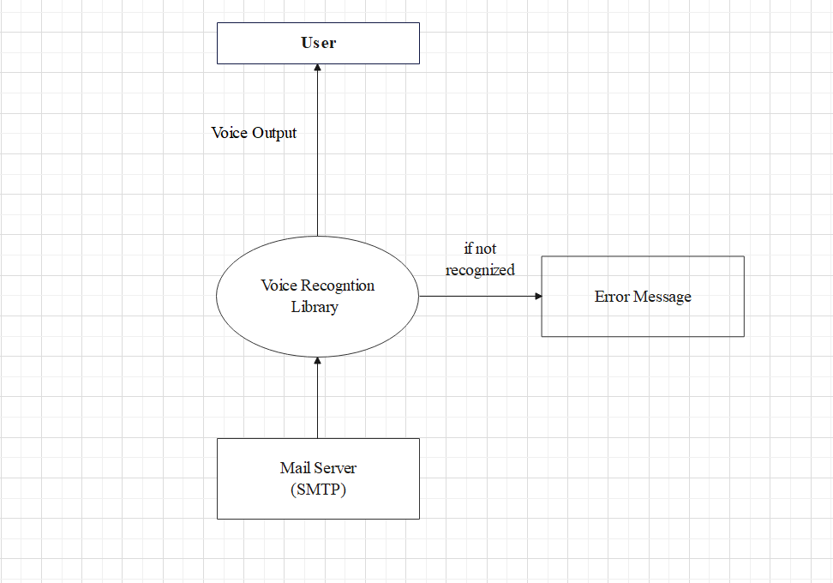

DFD level 2 (for receive mail)

1. Activity Diagram

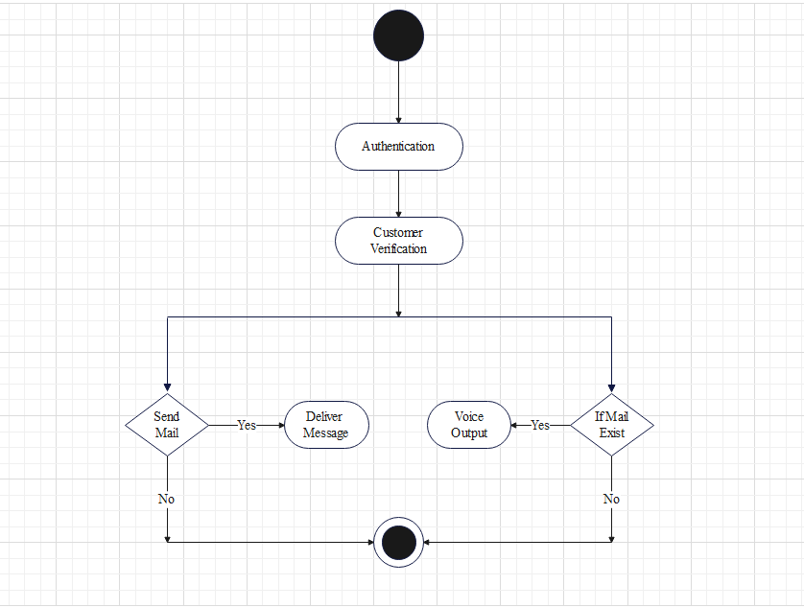

1. Sequence Diagram

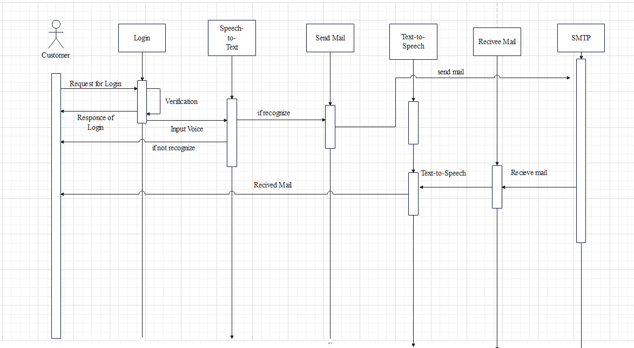

1. ER-Diagram

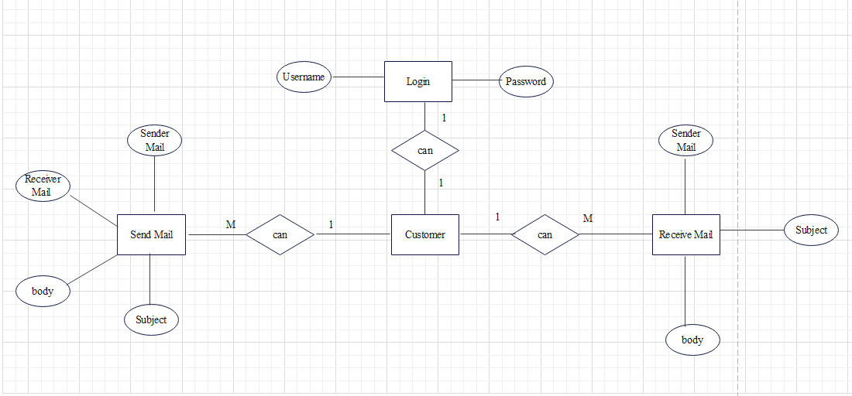

1. Design User Interface

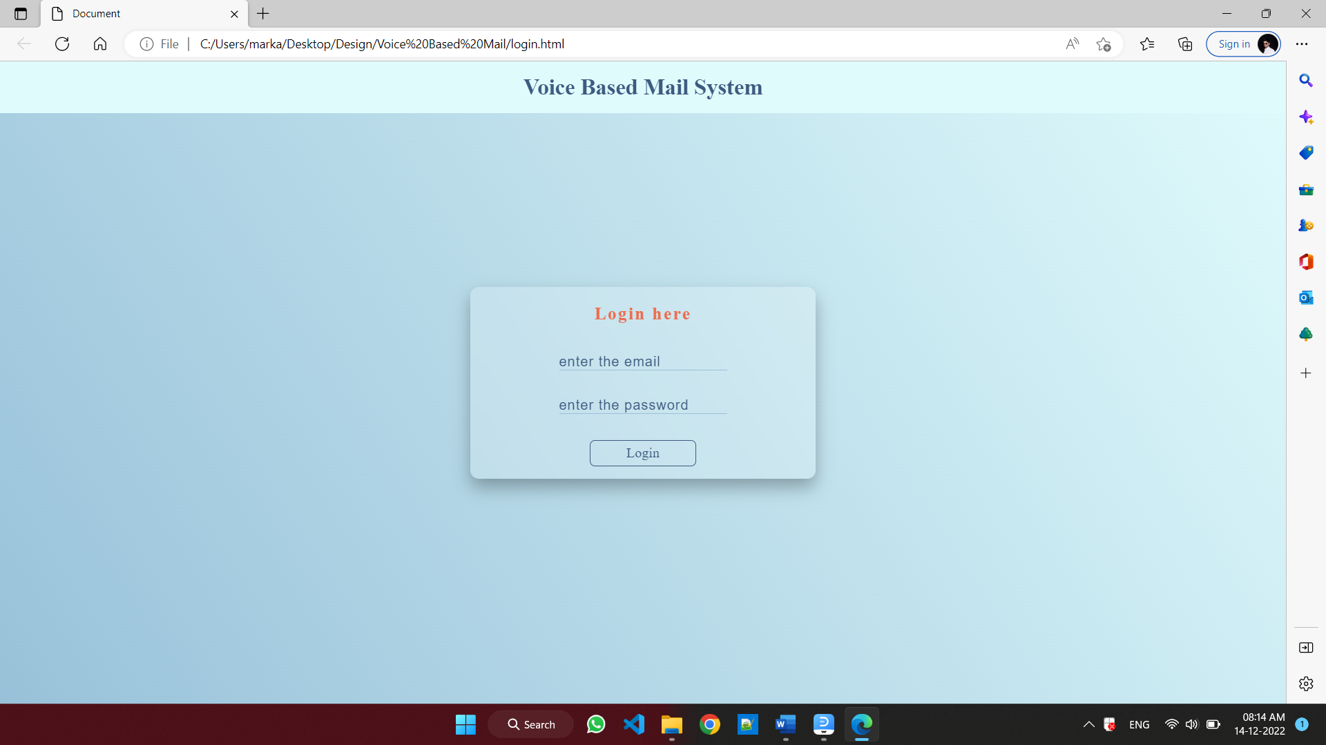

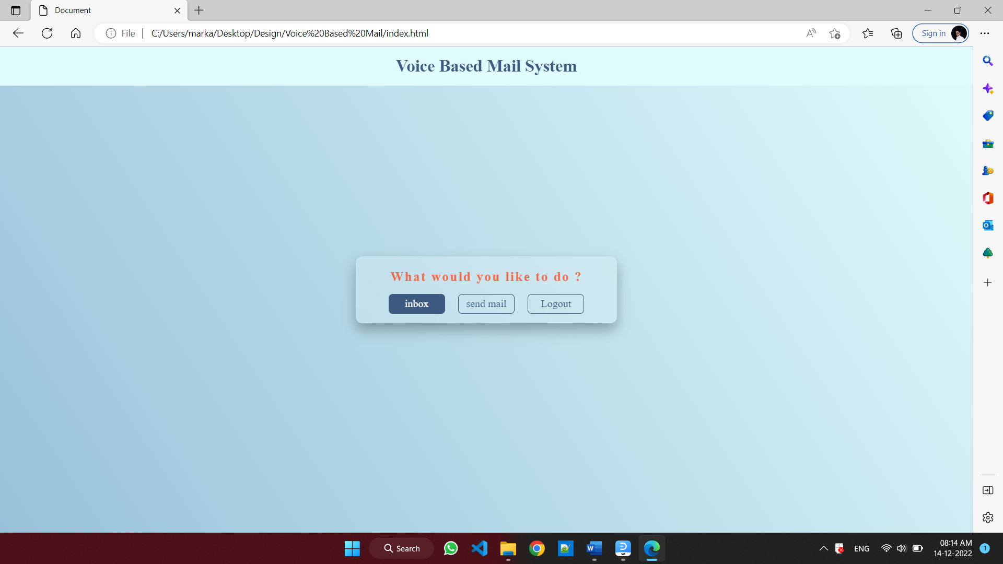

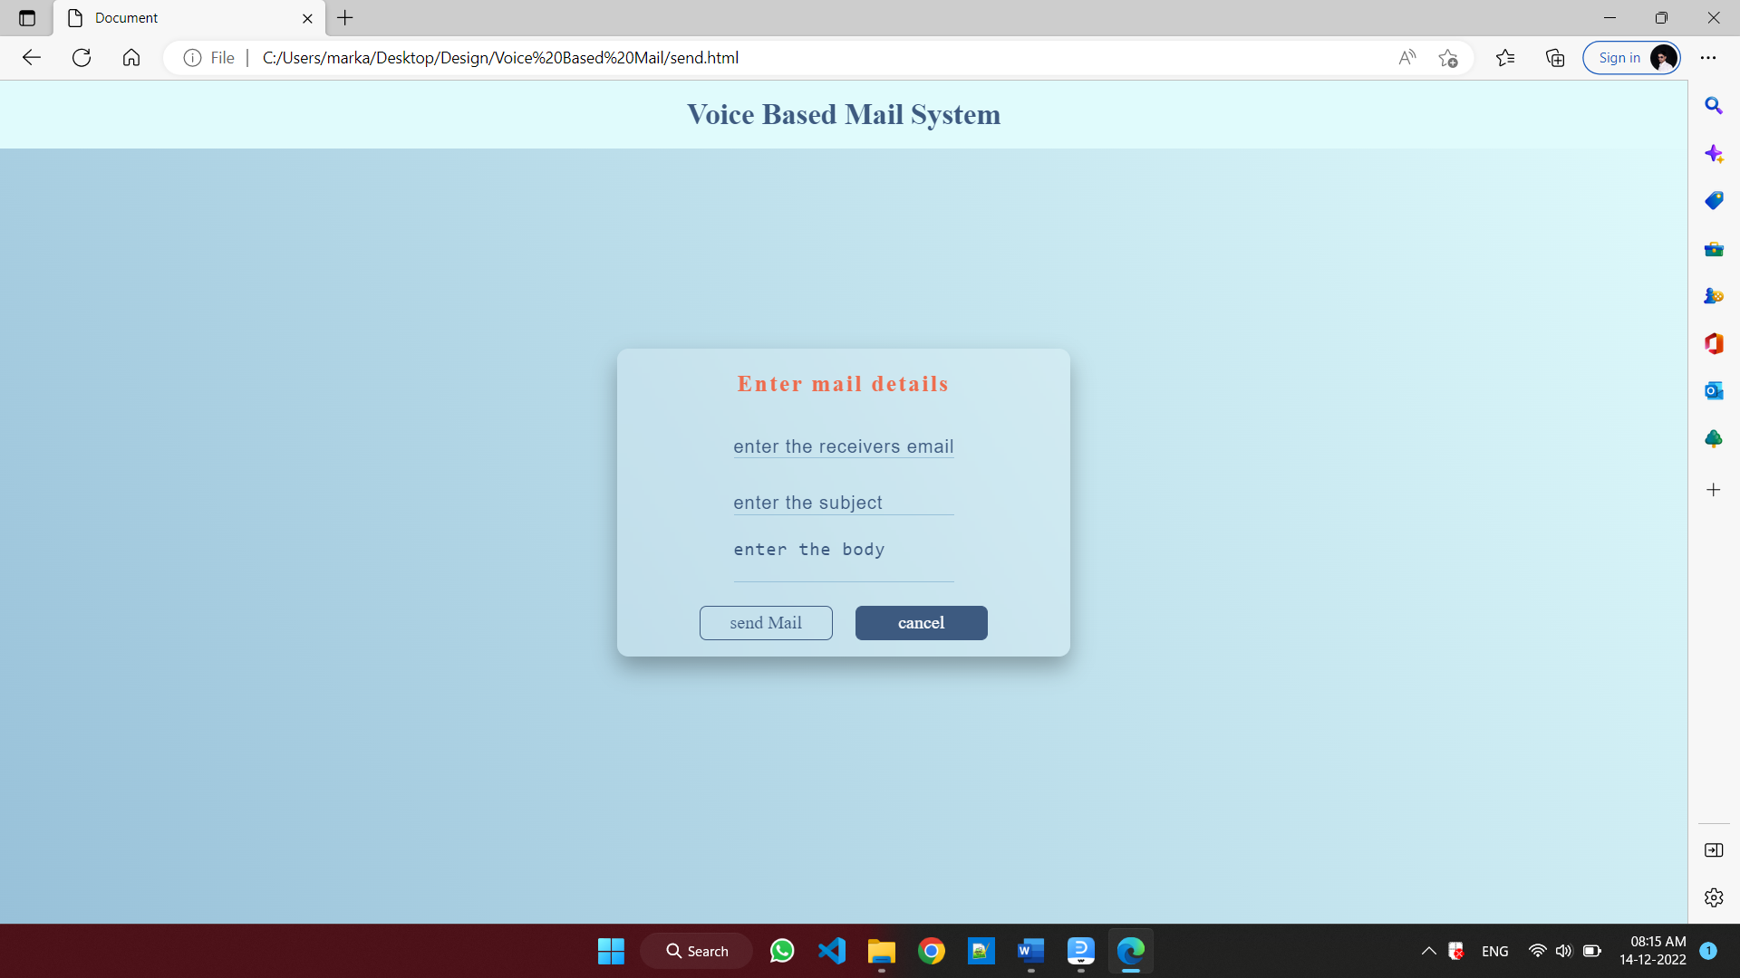

# Chapter 5

* 1. **Future Scope :**

For the further development of the application , the attachments like images, word documents, audio and video files can be incorporated. Encryption and decryption algorithm can used to protect the username and password that is passed during login. More commands can be used to for different operations like search, mark important, delete, archive, go back, report spam, forward. Automated replying to received mails can be also integrated. The application can be adapted to different languages such that a variety of users can use the application.

* 1. **Limitation :**
* Some people cannot use the voice-messaging systems.
* Difficult for people to recall which options they used previously.
* You will get tired of listening to the messages and end up deleting the messages without
* listening to them, This causes you to miss the important messages.

**Chapter 6**

* 1. **Books Referred :**
  2. **Web References :**

**Conclusion :**

This project proposes an web, designed specifically for visually challenged people. This web provides a voice based mailing service where they could read and send mail on their own, without any guidance. Here the users have to use certain keywords which will perform certain actions for e.g. Received mails, Send mails, Compose Mail. VMAIL can be used by a blind person to access mails easily and efficiently. Thus reliance of visually impaired on other people for their activities related to mail can be reduced.

**Appendix-B**

**Evaluation Sheet(ESE)**

**For**

**Capstone Project Planning**

Name of the student:-

Enrollment No:-

Name of the Program:- Semester:-

Course Title and Code:-

Title of the Capstone Project:-

**A. POs addressed by the capstone project**(Mention only those predominant POs)

**B. COs addressed by the capstone project**(Mention only those predominant COs)

**C. Other learning outcomes achieved through this project**

**1. Unit Outcomes(Cognitive Domain)**

**2. Practical Outcome(in Psychometer Domain)**

**3. Affective Domain Outcomes**

|  |  |  |  |
| --- | --- | --- | --- |
| **PROGRESSIVE ASSESSMENT(PA) Sheet** | | | |
| Sr  No. | Criteria | Max Marks | Marks Obtained |
| 1. | Problem Identification/Project Title | 10 |  |
| 2. | Industrial survey And Literature Review |
| 3. | Punctuality and overall contribution |
| 4 | Project Diary |
| 5 | Report Writing including documentation | 10 |  |
| 6 | Presentation | 05 |  |
| Total | | 25 |  |

**Name and Signature of Project Guide**